Insert school header here

Unit 3 Examination, 2016

Answer key

CHEMISTRY

Section One: Multiple-choice 25% (50 marks)

1 | D | 14 | B
2 | A | 15 | C
3 | D | 16 | C
4 | C | 17 | D
5 | A | 18 | A
6 | B | 19 | C
7 | B | 20 | A
8 | B | 21 | A
9 | B | 22 | C
10 | D | 23 | A
11 | D | 24 | C
12 | B | 25 | C
13 | D
Section Two: Short answer 35% (70 Marks)

This section has nine (9) questions. Answer all questions. Write your answers in the spaces provided.

When calculating numerical answers, show your working or reasoning clearly. Express numerical answers to the appropriate number of significant figures and include appropriate units where applicable.

Spare pages are included at the end of this booklet. They can be used for planning your responses and/or as additional space if required to continue an answer.
- Planning: If you use the spare pages for planning, indicate this clearly at the top of the page.
- Continuing an answer: If you need to use the space to continue an answer, indicate in the original answer space where the answer is continued, i.e. give the page number. Fill in the number of the question that you are continuing to answer at the top of the page.

Suggested working time: 60 minutes.

Question 26 (9 marks)

Write equations for any reactions that occur in the following procedures. If no reaction occurs, write ‘no reaction’.
In each case describe in full what you would observe, including any: colours; odours; precipitates (give the colour).

- Solid chromium(III) hydroxide is added to ethanoic acid. (3 marks)

Equation Cr(OH)₃ + 3 CH₃COOH Cr³⁺ + 3 CH₃COO⁻ + 3 H₂O
Correct species ✓ Correctly balanced ✓ Must have correct species for balancing mark. Award 1 mark for correctly balanced non-ionic equation
Observation Green solid dissolves in c/less solution to form c/less solution ✓

- 1 mol L⁻¹ aqueous solutions of lead(II) nitrate and hydrochloric acid are mixed. (3 marks)

Equation Pb²⁺ + 2 C⁻ PbC₂
Correct species ✓ Correctly balanced ✓ Must have correct species for balancing mark. Award 1 mark for correctly balanced non-ionic equation
Observation Two c/less solutions form white ppt in c/less solution ✓

- A strip of zinc is dipped in a 1 mol L⁻¹ solution of sulfuric acid. (3 marks)

Equation Zn + 2 H⁺ Zn²⁺ + H₂
Correct species ✓ Correctly balanced ✓ Must have correct species for balancing mark. Award 1 mark for correctly balanced non-ionic equation
Observation Silver/grey solid dissolves in c/less solution to form bubbles of c/less gas in c/less solution ✓

Question 27 (5 marks)

Tetrafluoroethene (C₂F₄) is an important feedstock in the manufacture of polymers. Its production takes place via a series of reactions, the last of which is represented by the equation:
2 CHCF₂(g) $⇌$ C₂F₄(g) + 2 HC(g)

Some of the physical properties of the species shown in the equation are given in the table below:

Species | CHCF₂(g) | C₂F₄ | HC
Melting Point/°C | -146 | -142 | -114
Boiling Point/°C | -41 | -76 | -85

- Write an expression for the equilibrium constant, K, at the following temperatures: (2 marks)

Temperature | Equilibrium constant expression
25°C | ✓
-50°C | [C₂F₄][HCl]² ✓

The graph below shows the variation in the concentration of C₂F₄ present at equilibrium as the temperature of the system is changed.

- Explain what conclusion about the enthalpy change for the formation of tetrafluoroethene can be drawn from the graph. (3 marks)

The enthalpy change is negative ✓
Rising temperature causes the exothermic reaction to be favoured ✓
Since more products have formed, the forward reaction must be exothermic ✓
Question 28 (8 marks)

When ammonia solution is added to an aqueous solution of nickel(II) chloride, the following reversible reaction takes place:

[Ni(H₂O)₆]²⁺(aq) + 6 NH₃(aq) $⇌$ [Ni(NH₃)]²⁺(aq) + 6 H₂O()
green deep blue

Two test tubes were set up, each containing some of this equilibrium mixture. A different change was imposed upon each test tube. Complete the following table, stating and explaining the observations that would be made. No equations are required.

Imposed change | Expected observation | Explanation
A small amount of distilled water is added | The colour of the solution becomes less intense ✓ | Adding water lowers the concentration of all ions ✓  Equal numbers of ions on both sides of equation, so chances of collision between reactants falls by same factor as chances of collision between products ✓  No shift in equilibrium ✓
A small amount of ammonia gas is bubbled through the solutions | The colour of the solution becomes more blue (or less green) ✓ | Adding ammonia increases [NH₃(aq)] and chances of collision between reactants ✓  Chances of collision between products unaffected ✓  Forward reaction favoured ✓

Question 29 (5 marks)

The graph below shows how the kinetic energy of the particles in a sample of gas is distributed at a particular temperature.

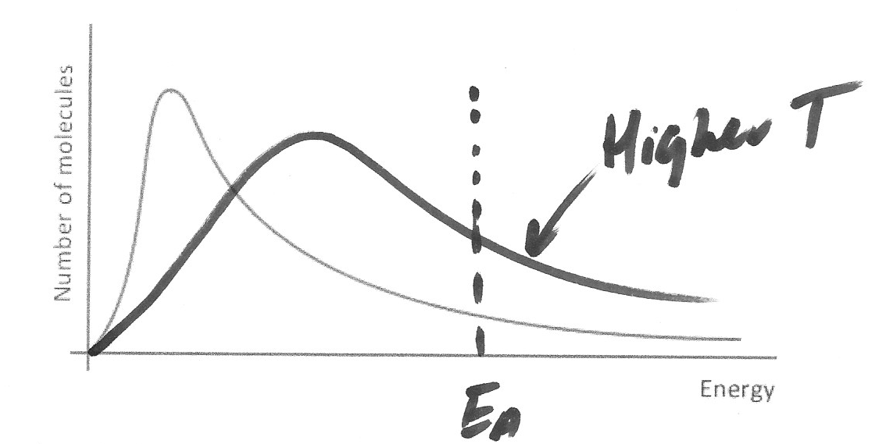

Use the graph, and your understanding of collision theory, why increasing temperature by a relatively small amount will have a dramatic effect upon the rate of a chemical reaction.
(5 marks)

Sketch to include:
Peak at higher energy ✓
Starts at origin and crosses original curve only once ✓
E_{a} marked at some point on x-axis ✓

Explanation:
At higher T, a much greater percentage of particles have enough energy to exceed E_{a} ✓
This linked to area under curve to the right of E_{a} ✓
Question 30 (12 marks)

A student carrying out an investigation into some common laboratory reagents placed 1 mol L⁻¹ solutions of ethanoic acid, hydrochloric acid, and sulfuric acid into three separate beakers. She later realised that she had failed to label the beakers.

The values of the acid dissociation constants, K_{a}, for the three acids are shown in the table (N/A denotes that the respective K_{a} value is not applicable):

Acid | K_{a} (1st ionisation) | K_{a} (2nd ionisation)
Hydrochloric acid | N/A | N/A
Ethanoic acid | 1.74 x 10⁻⁵ | N/A
Sulfuric acid | N/A | 0.0102

- Using appropriate chemical equations, explain how the student could have used a pH probe and the data in the table to determine which of the acids was in which beaker. (6 marks)

Hydrochloric acid is strong and monoprotic, so [H⁺] = 1 mol L⁻¹, so pH = 0.1
HC + H₂O H₃O⁺ + C⁻

Ethanoic acid is weak and monoprotic, so [H⁺] < 1 mol L⁻¹, so pH > 1
CH₃COOH + H₂O $⇌$ CH₃COO⁻ + H₃O⁺

Sulfuric acid’s first ionisation is strong, second is weak, so 1 mol L⁻¹ < [H⁺] < 2 mol L⁻¹, so pH < 1
H₂SO₄ + H₂O HSO₄⁻ + H₃O⁺
HSO₄⁻ + H₂O $⇌$ SO₄²⁻ + H₃O⁺

1 mark for correct equation/s for each acid (allow equations that do not use water and give H⁺ instead of H₃O⁺ - state symbols are not needed)
1 mark for each correct statement about [H⁺] and link to pH

- Explain why there is no K_{a} value quoted for hydrochloric acid. (2 marks)

Hydrochloric acid is a strong acid and is therefore completely dissociated (or [undissociated HC] = 0) ✓
Since [undissociated HC] is the denominator of K_{a}, the value of K_{a} would be infinity ✓
- Write an expression for the dissociation constant, K_{a}, of ethanoic acid. (1 mark)

K_{a} = [CH₃COO⁻][H₃O⁺] / [CH₃COOH] ✓

- Use the value of K_{a} for ethanoic acid to calculate the percentage of ethanoic acid molecules that are dissociated in a 1 mol L⁻¹ solution (to make the calculation simpler, you may use the approximation that the concentration of undissociated molecules is equal to 1 mol L⁻¹).
(3 marks)

K_{a} = [CH₃COO⁻][H₃O⁺] / 1, K_{a} = [H₃O⁺]² ✓
[H⁺] = √1.74 x 10⁻⁵ = 4.17 x 10⁻³ ✓
∴% ionisation = 4.17 x 10⁻³ x 100% = 0.417% ✓

Question 31 (6 marks)

Complete the table by writing the name or formula for the conjugate base, species X, or conjugate acid in each blank space as appropriate. Species X is the species that is able to form both the respective conjugate acid and conjugate base.

Conjugate base | Species X | Conjugate acid
NH₂⁻ | NH₃ or ammonia ✓ | NH₄⁺ or ammonium ✓
SO₃²⁻ or sulfite ✓ | HSO₃⁻ Hydrogensulfite ✓ | Sulfurous acid
HPO₄⁻ or hydrogenphospahate ✓ | Dihydrogenphosphate ion | H₃PO₄ or phosphoric acid ✓

Question 32 (7 marks)

Acid-base indicators are usually able to exist as conjugate pairs, the two of which can be represented as “HIn” and “In⁻”, and will have different colours from one another. The two forms will exist in equilibrium in aqueous solution, as shown in the equation:

HIn(aq) + H₂O() $⇌$ In⁻(aq) + H₃O⁺(aq)

Like other weak acids, the degree to which an indicator dissociates in solution can be expressed using the indicator’s dissociation constant, K_{a}.

- Use appropriate chemical equations, and your understanding of equilibrium principles, to explain how the addition of limewater (an aqueous solution of calcium hydroxide) to a solution containing an indicator can lead to a change in the colour of the solution. (4 marks)

OH⁻ ions in limewater react with H₃O⁺
OH⁻ + H₃O⁺ 2 H₂O ✓
[H₃O⁺] falls, reducing rate of backward reaction, since collisions are less frequent ✓
Forward reaction rate unaffected, so forward reaction is favoured ✓
[In⁻] increases as [HIn] falls, giving rise to colour change (since they are different colours) ✓

The pH at which an indicator changes colour is known as its end point. A solution with this pH will have equal concentrations of the two forms, HIn and In⁻.

- The indicator methyl yellow has a K_{a} value of 7.94 x 10⁻⁴. Use the information above to calculate the pH at the end point for this indicator. (3 marks)

Since [In⁻] = [HIn], K_{a} = [H⁺] ✓
pH = -log [H⁺] ✓
pH = 3.1 ✓
Question 33 (7 marks)

- Give the oxidation number of the bold element in each of the following: (3 marks)

- S₈ 0 ✓
- H₂S -2 ✓
- A(NO₃)₃ +5 ✓

The reaction in acidic solution between hydrogen sulfide, H₂S, and nitrate ions, NO₃⁻, produces sulfur, S₈, and nitrogen monoxide, NO.

- Complete the table to show the reduction and oxidation half-equations, and the overall balanced redox equation for the reaction that takes place. (4 marks)

Reduction half-equation | NO₃⁻ + 4 H⁺ + 3 e⁻ NO + 2 H₂O
Oxidation half-equation | 8 H₂S S₈ + 16 H⁺ + 16 e⁻
Overall equation | 16 NO₃⁻ + 16 H⁺ + 24 H₂S 16 NO + 32 H₂O + 3 S₈

Each correct equation scores 1
Oxidation/reduction correctly identified scores 1
Correct combination scores 1

Question 34 (11 marks)

The cell, Cu(s) I Cu²⁺(aq) II Pt [C₂](g) I C⁻(aq), was set up as shown in the diagram below. Beaker A was filled with a 1.00 mol L⁻¹ aqueous solution of ammonium chloride, and the filter paper shown in the diagram was soaked in an aqueous solution of potassium nitrate before being placed in the two beakers.

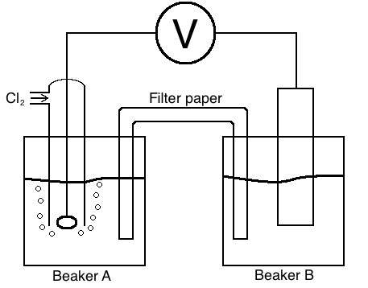

- Give a reason why platinum was a suitable material from which to construct the electrode in beaker A. (1 mark)

Very unreactive or doesn’t create its own potential ✓

- Give the name or formula of a suitable electrolyte for use in beaker B. (1 mark)

Aqueous copper sulfate or copper sulfate solution (or other soluble copper salt). Do not allow “copper sulfate” or other non-aqueous salts ✓

- Give two reasons why potassium nitrate was a suitable material for soaking the filter paper.
(2 marks)

Strong electrolyte, so conducts electricity ✓
Neither ion will form precipitates ✓

- Calculate the cell potential (E°) you would expect to measure for the cell. (1 mark)

E° = 1.36 – 0.34 = 1.02 V ✓
- Give a reason why the measured cell potential might differ from the value calculated in
part (a). (1 mark)

Reaction not carried out at 25°C, or solutions not 1 mol L⁻¹, or Cl₂ not at 1 atm ✓

- State an observation that would be made in beaker B during the operation of the cell. (1 mark)

Blue colour becomes more intense (allow electrode dissolves/loses mass) ✓

- State and explain what would happen to the voltmeter reading if a few drops of an aqueous solution of silver nitrate were placed in beaker A. (4 marks)

Ag⁺ + Cl⁻ AgCl (or explanation that silver ions will cause precipitation of AgCl) ✓
[Cl⁻] falls, causing the equilibrium Cl₂ + 2e⁻ $⇌$ 2 Cl⁻ to shift to the right ✓
Chlorine half cell becomes more positive (or less negative) ✓
Voltmeter reading should increase (i.e. number becomes larger) ✓

End of section two
Section Three: Extended answer 40% (80 marks)

This section contains five (5) questions. You must answer all questions. Write your answers in the spaces provided.

Where questions require an explanation and/or description, marks are awarded for the relevant
chemical content and also for coherence and clarity of expression. Lists or dot points are unlikely to gain full marks.

Final answers to calculations should be expressed to the appropriate number of significant figures.

Spare pages are included at the end of this booklet. They can be used for planning your
responses and/or as additional space if required to continue an answer.

- Planning: If you use the spare pages for planning, indicate this clearly at the top of the page.
- Continuing an answer: If you need to use the space to continue an answer, indicate in the
original answer space where the answer is continued, i.e. give the page number. Fill in the
number of the question that you are continuing to answer at the top of the page.

Suggested working time: 70 minutes.

Question 35 (19 marks)

Rising carbon dioxide levels in the atmosphere are believed to play an important role in the life of organisms known as calcifiers, a group that includes many forms of coral and crustaceans. These organisms use a precipitation reaction between calcium ions and carbonate ions present in sea-water to form shells and skeletons.

Measurements have detected a fall of around 0.1 in the pH of the oceans since the beginning of the industrial revolution at the end of the 18th century, which scientists believe can be attributed to an increase in the partial pressure of carbon dioxide in the atmosphere over the same period.

- Use appropriate chemical equations to explain why a rise in the partial pressure of carbon dioxide in the atmosphere can cause the pH of the oceans to fall. (3 marks)

CO₂ + H₂O $⇌$ H₂CO₃ ✓
H₂CO₃ + H₂O $⇌$ HCO₃⁻ + H₃O⁺ ✓
Increased concentration of H₃O⁺ causes pH to fall ✓

- The carbonate ions used by calcifiers exist in equilibrium with hydrogencarbonate ions in sea-water. Use appropriate chemical equations and your understanding of equilibrium to explain what effect a fall in the pH of the ocean would have on the availability of carbonate ions. (3 marks)

HCO₃⁻ + H₂O $⇌$ CO₃²⁻ + H₃O⁺ ✓
Increasing [H⁺] causes more frequent collisions between products (but reactant collision frequency unaffected), hence reverse reaction is favoured ✓
CO₃²⁻ gets used up and [CO₃²⁻] falls ✓

A student wished to investigate the composition of prawn shells. In order to do this, he decided to carry out a back titration. The steps carried out were as follows:

- The shells of 10 prawns were ground to a fine powder using a pestle and mortar.
- The powder was dried in an oven at 80°C for three days.
- 2.17 g of the powder was placed in a beaker, and 50.0 mL of 1.20 mol L⁻¹ nitric acid (an excess) was added to the beaker and the mixture heated on a Bunsen.
- The resulting mixture was filtered into a 250 mL volumetric flask, the beaker and filter paper rinsed thoroughly, and the rinsings added to the flask, before making up to the line with distilled water.
- 20.0 mL aliquots of the solution in the volumetric flask were titrated against a standard solution of sodium hydroxide with a concentration of 0.0502 mol L⁻¹. All readings were taken from the top of the meniscus.

The results of the titration are given in the following table:

Final | 37.10 | 35.10 | 35.05 | 35.25 | 36.05 | 35.75
Start | 0.00 | 0.10 | 0.00 | 1.25 | 0.00 | 0.65
Titre / mL | 37.10 | 35.00 | 35.05 | 34.00 | 36.05 | 35.10

- Complete the results table and find the average titre volume. (2 marks)

Average titre = (35.00 + 35.05 + 35.10) / 3 = 35.05 mL
Titres correctly calculated ✓
Correct titres selected and average correctly calculated ✓

- Explain why the student needed to carry out a back titration. (1 mark)

Difficult to make a solution of calcium carbonate, since it is insoluble ✓

- Find the percentage by mass of calcium carbonate in this sample of prawn shell by calculation. (8 marks)

n(NaOH) = 0.0502 x 003505 (or answer to part c) = 1.76 x 10⁻³ mol ✓
n(HNO₃) in 20.0 mL = n(NaOH) = 1.76 x 10⁻³ ✓
n(HNO₃) in 250 mL = n(HNO₃) in XS = ans x 12.5 = 0.0220 mol ✓
n(HNO₃) that reacted with CO₃²⁻ = n(HNO₃) total – n(HNO₃) XS ✓
= 0.0500 x 1.20 – ans = 0.0380 mol ✓
n(CO₃²⁻) = ½ n(HNO₃) reacted = 0.0190 mol ✓
m(CaCO₃) = ans x 100.09 = 1.90 g ✓
% by mass = (1.90 / 2.17) x 100% = 87.7% ✓

- State and explain what effect the student’s decision to read the burette from the top of the meniscus would have had on the calculated percentage by mass. (2 marks)

Effect on calculated percentage (circle one) | Artificially high | No effect ✓ | Artificially low

Explanation

Since titres are a difference between two readings, the errors in the two readings would cancel out ✓
Question 36 (12 marks)

The electrolysis of aqueous solutions plays an extremely important role in industry. These reactions can be carried out on a small scale in the laboratory using standard laboratory equipment.

An aqueous solution of copper sulfate can be electrolysed using either inert electrodes or copper electrodes. Discuss the important similarities and differences between these two methods of electrolysis. Your answer should pay particular attention to the following areas, and credit is given for the quality of your written communication.

- How the cells can be constructed
- The processes occurring at each electrode
- Observations made at each electrode
- Appropriate chemical equations
- Role of the electrolyte
- Reasons for the industrial importance of the process

External power supply connected to two electrodes ✓
Inert electrodes could be made of carbon/platinum ✓
Electrolyte allows current to flow since its ions move to oppositely charged electrodes ✓
Positive electrode is the anode, and negative is the cathode ✓
Oxidation takes place at anode, reduction at cathode ✓
Positive electrode is where water is oxidized to form oxygen and H⁺ ions ✓
equation given: 2 H₂O O₂ + 4 H⁺ + 4 e⁻ ✓
bubbles of colourless gas are observed ✓
For inert electrodes, negative electrode is where water is reduced to form hydrogen and hydroxide ions ✓
equation given: 2 H₂O + 2 e⁻ H₂ + 2 OH⁻ ✓
bubbles of colourless gas are observed ✓
For copper electrodes: ✓
negative electrode is where copper ions are reduced to form copper ✓
equation given: Cu²⁺ + 2 e⁻ Cu ✓
solution is observed to turn less blue (allow negative electrode gains mass/salmon pink solid appears on electrode and/or positive electrode loses mass/dissolves) ✓
The electrolysis of copper sulfate is important in the purification of copper ✓

Any 11 points score 11 marks
1 mark awarded for points laid out in a clear/logical format, and expressed using correct terminology. Do not award this mark for a list of dot points.

Question 37 (21 marks)

Propanoic acid, CH₃CH₂COOH, is a weak monoprotic acid that is produced by bacteria in the skin that cause acne. In an experiment to determine the concentration of an aqueous solution of propanoic acid, a student reacted a 25.0 mL aliquot of the solution with a standardised 0.976 mol L⁻¹ solution of sodium hydroxide in a conical flask, using a pH probe and data logger to monitor the pH. Some of the student’s results are shown in the table below.

Volume of NaOH (mL) | 20.75 | 20.80 | 20.85 | 20.90 | 20.95 | 21.00 | 21.05 | 21.10 | 21.15
pH of solution | 4.7 | 5.3 | 5.2 | 5.6 | 7.9 | 12.7 | 13.0 | 13.2 | 13.3

- Explain why a failure to standardise the sodium hydroxide solution would have led to a systematic error, and what effect it would have on the calculated value for the concentration of the acid. (3 marks)

NaOH is hygroscopic/absorbs water
Systematic error since [NaOH] would always be lower than expected
It would appear that a larger amount of moles of NaOH were used than was the case, leading to an artificially high value for the acid concentration

- Plot the results from the experiment on the graph paper provided below, and use your graph to estimate the pH at the equivalence point. (5 marks)
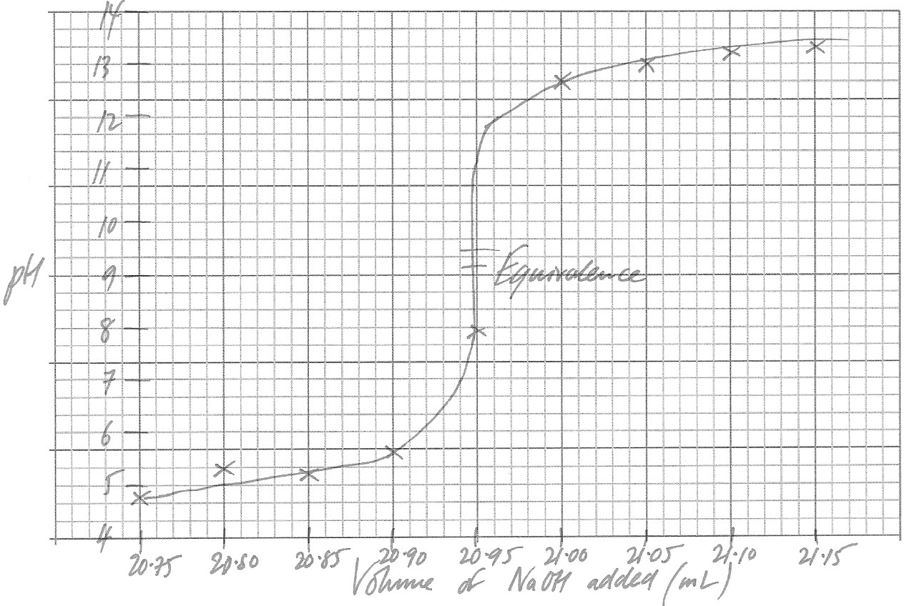
1 mark each for:
axes correctly labelled and with volume on x-axis
linear scales on axes
points plotted correctly
smooth curve with a close-to-vertical section

Estimated pH at equivalence: ~ 9.2 – 9.4 (or sensible value taken from half way up the vertical section of candidate’s graph) ✓
Use appropriate equations to explain the pH at the equivalence point of this titration. (3 marks)

Only substances present at equivalence are sodium propanoate and water ✓
The sodium ion is neutral, whilst propanoate is basic ✓
Equation given to show basicity of propanoate (CH₃CH₂COO⁻ + H₂O $⇌$ CH₃CH₂COOH + OH⁻) ✓

Use appropriate equations to explain why the reaction mixture in the flask was able to act as a buffer after the addition of 10 mL of sodium hydroxide. (4 marks)

At this point, the mixture contains both propanoic acid and sodium propanoate ✓
CH₃CH₂COOH + H₂O $⇌$ CH₃CH₂COO⁻ + H₃O⁺ ✓
Addition of acid/H⁺ increases [H₃O⁺] and pushes equilibrium to left, absorbing H⁺ ✓
Addition of base/OH⁻ reduces [H₃O⁺] since they react to form water, so equilibrium shifts right and absorbs OH⁻ ✓

After repeating the experiment a number of times, the student found the concentration of the propanoic acid solution was 0.815 mol L⁻¹.

Use the data provided to calculate the pH of the mixture in the flask after 30.0 mL of sodium hydroxide had been added to the 25.0 mL aliquot of propanoic acid. (6 marks)

n(OH⁻) = 0.0300 x 0.976 = 0.0293 mol
and n(CH₃CH₂COOH) = 0.0250 x 0.815 = 0.0204 mol ✓
n(OH⁻) in XS = 0.0293 – 0.0204 = 8.905 x 10⁻³ mol ✓
total volume = 0.0250 + 0.0300 = 0.0550 L ✓
[OH⁻] = 8.905 x 10⁻³ / 0.0550 = 0.162 mol L⁻¹ ✓
[H⁺] = 1 x 10⁻¹⁴ / ans = 6.18 x 10⁻¹⁴ ✓
pH = -log (ans) = 13.2 ✓

Question 38 (16 marks)

Ammonia is amongst the top ten most produced chemicals in the world. It is an essential feedstock in the manufacture of fertilisers, as well as playing an important role as a complexing agent in the mining industry. The manufacture of ammonia on an industrial scale is carried out using the Haber process, which relies on the reversible reaction of nitrogen and hydrogen in the presence of an iron catalyst, as shown in the equation:

N₂(g) + 3 H₂(g) $⇌$ 2 NH₃(g) ΔH = - 92 kJ mol⁻¹

The conditions for the reaction in industry must be chosen carefully, taking into consideration not only the yield, but also the rate of the reaction. Commonly, a temperature of around 500°C is used, and the reaction operated at a pressure of around 20,000 kPa. Since ammonia has a much higher boiling point than the other gases, it can easily be removed from the equilibrium mixture by condensation.

- In the space provided below, draw a fully labeled enthalpy level diagram to show the reaction between nitrogen and hydrogen in the Haber process, in the presence and absence of an iron catalyst. (4 marks)

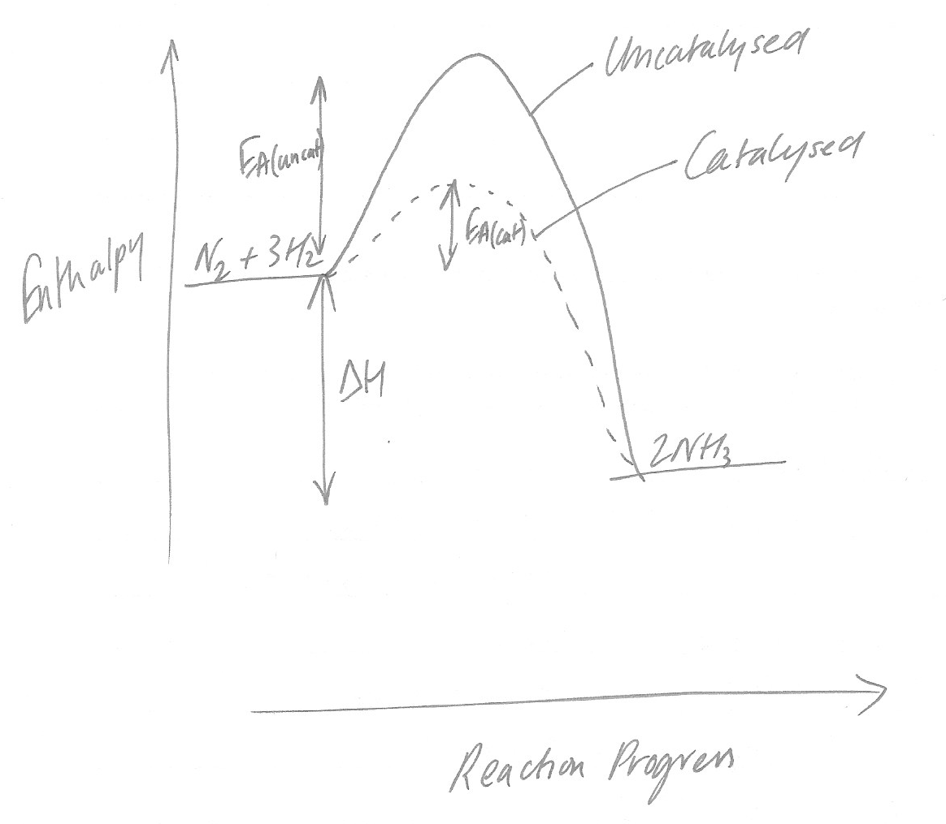
1 mark each for the following
exothermic reaction shown (i.e. N₂ and H₂ at higher enthalpy than NH₃)
ΔH correctly labelled
E_{a} correctly labelled
E_{a} lower with iron catalyst than without

A sealed vessel containing an equilibrium mixture of nitrogen, hydrogen and ammonia was subjected to the following changes in conditions:

- At a time, t₁, the temperature of the vessel was increased
- At a time, eqm₁, the system had returned to equilibrium
- At a time, t₂, all ammonia was removed from the system
- At a time, eqm₂, the system had again returned to equilibrium

- Complete the following graphs to show what happens to the rates of the forward and backward reactions, and the concentrations of nitrogen and ammonia as these changes are made. (12 marks)

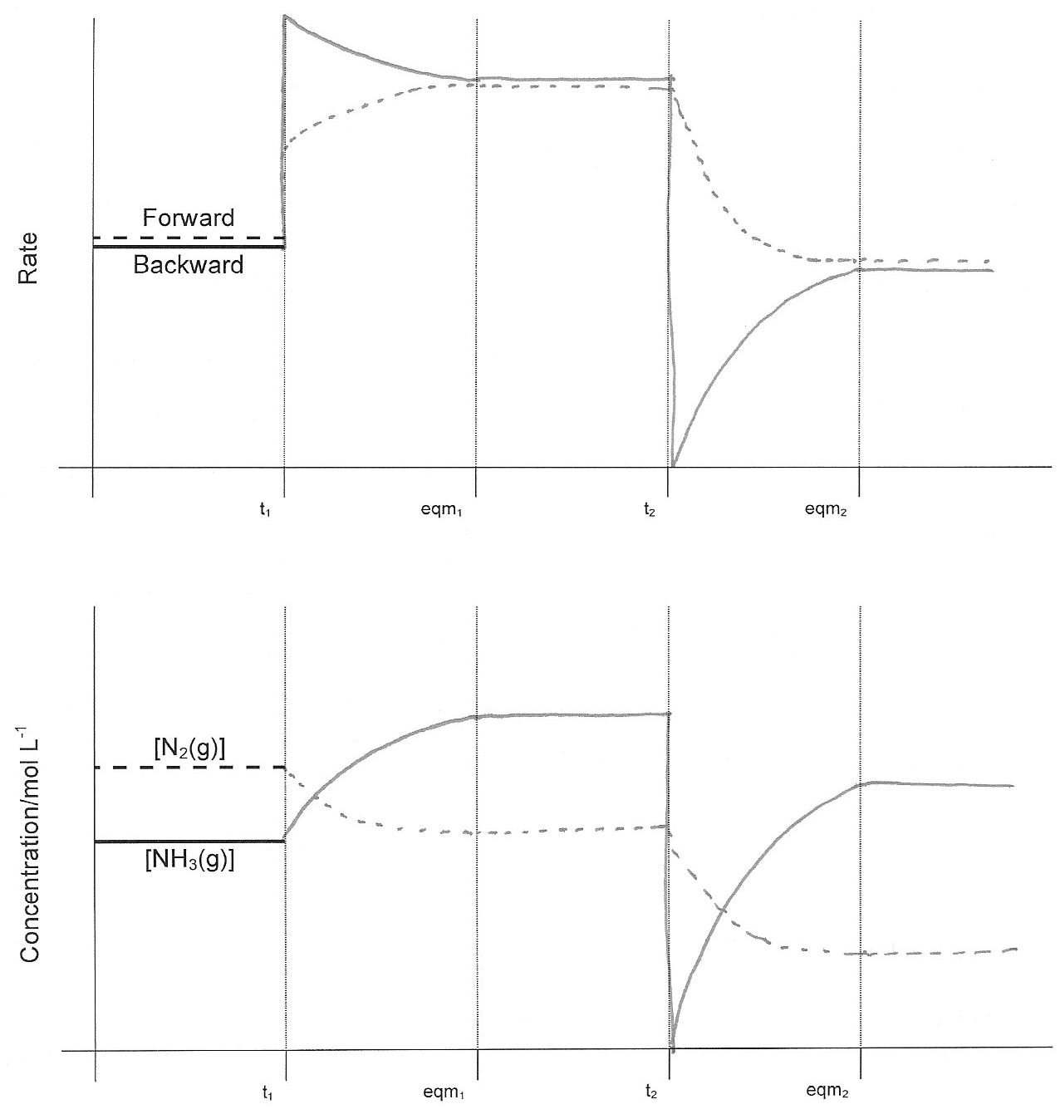
For rate-time graph
Both reactions speed up at t₁ ✓
Backward reaction speeds up by more than the forward reaction ✓
At t₂ Backward reaction falls to 0 ✓
Whilst forward reaction unchanged ✓
Both reactions coming together to same rate at each of the eqm positions ✓
For conc-time graph
[NH₃] rises between t₁ and eqm₁ ✓
[N₂] falls between t₁ and eqm₁ ✓
[NH₃] falls to zero at t₂ ✓
[NH₃] rises between t₂ and eqm₂ ✓
[NH₃] stops rising below the level it was at just before t₂ ✓
[N₂] falls between t₂ and eqm₂ ✓
recognition that [NH₃] changes by twice as much as [N₂] in response to changes ✓

Question 39 (12 marks)

Iron(II) sulfate can exist in many forms in nature, often in hydrated forms with the general formula FeSO₄.xH₂O.

Rozenite is a mineral composed of a hydrated form of iron(II) sulfate. A student wishing to find the formula of rozenite by titration dissolved a 2.45 g sample and reacted it with with a
0.0905 mol L⁻¹ solution of potassium permanganate. She found that 24.2 mL of the potassium permanganate solution was required for complete reaction.

State and explain what indication there would have been that the equivalence point had been reached in the student’s titration. (2 marks)

Solution would turn from c/less or very pale pink to purple ✓
Since at equivalence there would no longer be any Fe²⁺ ions available to turn MnO₄⁻ into Mn²⁺ ✓

Use the data provided to calculate the value of x and the formula of rozenite. (8 marks)

n(MnO₄⁻) = 0.0905 x 0.0242 = 2.19 x 10⁻³ mol ✓
n(FeSO₄) = n(Fe²⁺) = 5 x n(MnO₄⁻) ✓
= 5 x 2.19 x 10⁻³ = 0.0110 mol ✓
m(FeSO₄) = ans x 151.92 = 1.66 g ✓
m(H₂O) = m(sample) - m(FeSO₄) = 2.45 g - ans = 0.786 g ✓
n(H₂O) = ans / 18.016 = 0.0437 mol ✓
ratio FeSO₄ : H₂O = 0.0110 : 0.0437 ~ 4 ✓
formula is FeSO₄.4H₂O ✓

Identify one source of random error in the procedure and state how this error could be minimized. (2 marks)

Either the mass had a random error of +/- 0.005 g or the volume recorded had a random error of +/- 0.05 ✓
Error could be minimized by repeating the experiment and obtaining an average value ✓

End of questions

